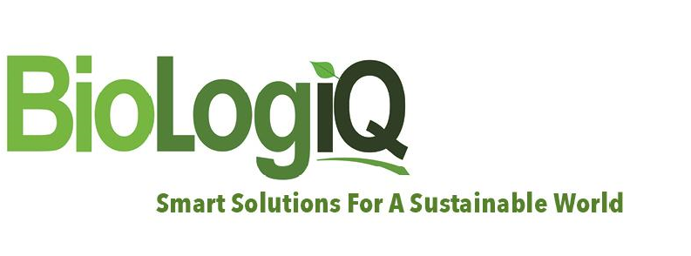

FOR IMMEDIATE RELEASE

BioLogiQ bolsters its global management strength by appointing a new CTO, CRO, and CFO

March 2, 2021 (IDAHO FALLS, ID)—BioLogiQ, Inc., a global innovator and manufacturer of sustainable bioplastic resins and biopolymers made from renewable resources, including its game-changing NuPlastiQ™, is announcing a reorganization of its C-Suite appointing David Parker as Chief Financial Officer, Ken Kramer as Chief Technology Officer, and Alberto Ulriksen as Chief Revenue Officer.

David Parker is a seasoned entrepreneur, operator, and advisor who brings over 40 years of global financial and business management experience across a myriad of industries. He is a highly respected and skilled financial and investment manager and has extensive experience helping successfully scale technology companies. David is a Partner with SRS Capital Partners, a boutique private equity and advisory partnership, and also Co-Founder and CEO of SRS Family Office Partners, a collaborative Family Office Advisory and Partnership created with the express purpose of organizing, advising and/or managing Single Family Offices.

“David has been associated with BioLogiQ for years. He is not only one of the smartest men I know, but his integrity is also beyond reproach. I couldn’t think of anyone I would trust more to manage the finances at BioLogiQ during this crucial period of growth,” said Steven Sherman, CEO of BioLogiQ.

Ken Kramer drove innovation for Hill-Rom and Hillenbrand for over 14 years at which point he became Vice President of R&D for Early Light Industrial, a privately held large scale original equipment manufacturer of toys, consumer, and healthcare products. He has worked for Early Light for over 10 years and most recently as Director of New Business Development on plant-based Biomaterials and products. Ken’s intellectual patent portfolio includes over 100 patents from around the world.

“I am excited to expand my involvement from BioLogiQ Asia to the US to promote and expand the very innovative NuPlastiQ in plastic products,” Ken said. “NuPlastiQ is key to our vision to provide sustainable regenerative products for our customers.”

Alberto Ulriksen brings 30 years of international executive experience in petrochemicals, plastics, pharma and medical devices. Alberto´s experience comes from 18 years with Dow Chemical, where he moved from finance to sales, marketing, product, and business management and development. Most recently, Alberto was a Managing Director at Brenntag, part of a leading global chemicals distribution company.

Steve Sherman said, “Alberto is a quintessential multi-talented businessman who combines keen business acumen with strong leadership and commercial experience. Alberto will bring leadership, passion, and credibility to our global business efforts.”

About BioLogiQ
BioLogiQ, Inc’s is a leading developer and manufacturer of plant-based resins and biopolymers that enable material & energy reductions, recyclability, and/or biodegradability, in the production of plastic products helping to build a world free of pollution caused by plastics. BioLogiQ utilizes its proprietary process to produce NuPlastiQ™ Biopolymers from natural, renewable resources such as carbohydrates. NuPlastiQ resins contain 100% USDA certified bio based content, and have passed ASTM D6400 and EN 13432 protocols, leading to TUV certification for industrial composability and marine biodegradability. NuPlastiQ, in combination with polyolefins, styrenics and several other fossil or bio based polymers, reduces the use of fossil fuels and other non-renewable resources, and enables the bio-remediation of leaked plastics in the environment at very competitive costs. When NuPlastiQ is combined with traditional polyolefins, the resulting BioBlend XP and XD resins also reduce greenhouse gas generation. For more information, visit www.BioLogiQ.com or www.NuPlastiQ.com.

Contact: Tracy Scott | tracy.scott@biologiq.com

# # #

2400 East 25th Street, Idaho Falls, ID 83404 | Phone: 208.357.9650 | www.biologiq.com

