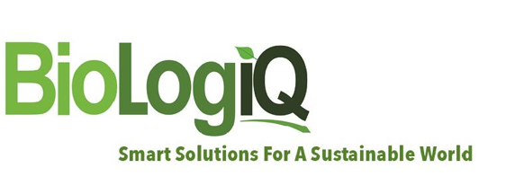

FOR IMMEDIATE RELEASE Contact: Tracy Scott | tracy.scott@biologiq.com

BioLogiQ’s NuPlastiQ® CG-1000 Can Accelerate Biodegradation of Traditional Polymers and Biopolymers

November 3, 2020 (IDAHO FALLS, ID)—BioLogiQ, Inc., a global innovator and manufacturer of plant-based biopolymers for use in the production of plastic products, announced today that NuPlastiQ® has been granted certification for OK Compost INDUSTRIAL and OK Compost HOME by TUV.
Alberto Ulriksen, BioLogiQ’s Chief Revenue Officer, said: “These certifications are a significant validation of the versatility and friendliness of NuPlastiQ’s dependable biodegradation performance. What’s more, they will enable our customers to achieve certification for their own products, helping customers know that they are committed to sustainability.”
The OK certifications are known and respected around the world. Having this certification guarantees that NuPlastiQ complies with the requirements of the EU Packaging Directive (94/62/EEC) and as such is biodegradable in both Industrial and Home composting environments. To achieve both of these stringent certifications, NuPlastiQ was subjected to several tests to meet the ASTM D-6400 and EN13432 certifications. The tests included heavy metal content, plant toxicity, biodegradation (which NuPlastiQ met in 1/3 of the time required), and disintegration (NuPlastiQ disintegrated 100% vs 90%, and in 1/3 of the time required).
NuPlastiQ can be used with PBAT, PBS, PLA, PHA etc. to produce a myriad of more environmentally friendly plastic products, from plastic bags, mulch film, and disposable gloves to packaging of all types. NuPlastiQ provides a broad value proposition for companies including enhancing biodegradability, decreasing the use of fossil-based, and other non-renewable, materials in plastic and reducing cost. NuPlastiQ is the only high-performance biopolymer that can be used with both polyolefins and bioplastics such as PBAT and PLA.

About BioLogiQ
BioLogiQ, Inc. is a leading developer and manufacturer of plant-based biopolymers for use in the production of plastic products that enable fossil-based material & energy reductions, efficient renewable content addition, and/or biodegradability. Its revolutionary NuPlastiQ® biopolymer, when combined with traditional polymers, creates BioBlend® XP and XD blended resins that also reduce greenhouse gas generation. NuPlastiQ® on the other hand, when combined with other biodegradable polymers to create BioBlend® BC blended resins, that enhance biodegradability and reduce costs. For more information, visit www.BioLogiQ.com.
About TUV Austria
TÜV AUSTRIA is an Austrian, independent testing, inspection and certification company with over 2,000 employees in more than 20 countries. The range of services of the TÜV AUSTRIA Group ranges from personal, system and product certification to testing of elevators and pressure equipment, system safety, training and further education, medical technology, electrical engineering, environmental protection, Industry 4.0, noise protection reports, carbon footprint evaluations, cyber security, Internet of Things, E-Mobility, AppChecks, calibrations, product tests, robotics, technical due diligence and legal compliance checks up to tests of stage, photovoltaic and wind power plants. For more information, visit www.tuv.at/en/home/.

# # #
2400 East 25th Street, Idaho Falls, ID 83404 | Phone: 208.357.9650 | www.BioLogiQ.com

